Question 1 :

Select round(avg(dep_delay)) as average_oF_dep_delay from flights where sched_dep_time>1300;

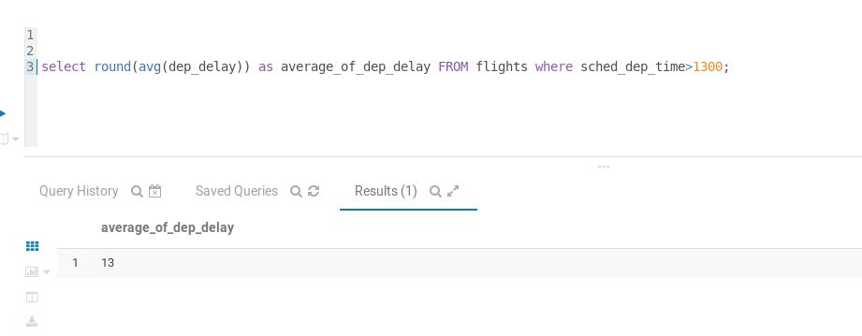

Question 2 :

Select round(avg(air_time)/60) as avg_air from fly.flights;

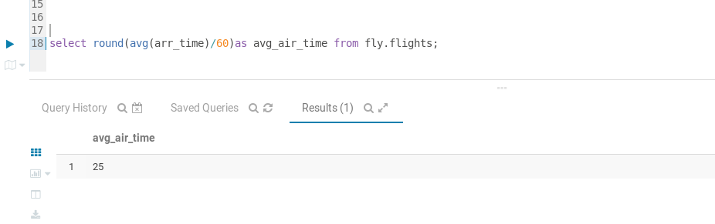

Question 3:

select manufacturer,count(*) from planes group by manufacturer having count(*)=1;

qno.4

SELECT origin, avg(dep_delay) from flights group BY origin having avg(dep_delay) > 30;

Q no.5

Select * from flights where carier =”AA” order by distance DESC, air_time asc;